Our Word Study List  - eat  - some  - was  - of  - girl  Word Family: Students should know how to read and write words with the _eat spelling pattern.  Examples: seat, beat | Mrs. Eberle’s Super Class News  News for the Week of October 16, 2017
Monday, October 16 2017

- Home practice packet

Tuesday, October 17, 2017

- Wear tennis shoes today for P.E.
- Home practice packet

Wednesday, October 18, 2017

- Home practice packet

Upcoming Events
10/16 – Welcome back to school!
10/19 – 50’s Day
11/3 – Zoo trip!
October
Birthdays

Travis 10/8
Lilly 10/11
Emma 10/17

Thursday, October 19, 2017

- 50’s Day! Wear your favorite 50’s attire!
- Return library book
- Home practice packet
Friday, October 20, 2017

- Return home practice packet
- Have a great weekend!

*PLEASE SEE OTHER SIDE.
Special Classes  Monday: Art  Tuesday: P.E.,  Wednesday: Music, guidance  Thurs: Library  Friday: Computer Lab  Lunch: 12:30-1:00  Although it rarely happens, lunch times are subject to change due to delays, special activities, etc.  *********************Principal’s Club  Effort: Jack S.  Character: Robert  Achievement: Brianne  Student of the Week:  Bella  Congratulations!  We are proud of you! | Notes:  *It is hard to believe that we have entered October and finished our first quarter of first grade. I will tell you that these awesome kiddos deserve some fun and relaxation after the hard work that they have been doing in class so far.  In reading this week we discussed how readers ask and answer questions as they read. You can practice this at home by having your child use these words (who, what, when, where, why, how) to ask questions about text and then read to see if the question is answered. We also practiced using clues from a text to make predictions.  In writing we have been focusing on writing a beginning, middle, and end and adding details to our stories. In math we wrapped up place value and everyone rocked it! We continue to work on our math fact mastery practice and solving story problems with various strategies. We also did some work with ordinal numbers.  * Due to all of your wonderful support, our class earned second place for the whole school in last week’s coin wars! We celebrated on Friday with ice cream.  *First grade will be having a field trip to the Louisville Zoo on Friday, November 4 and you are invited! This is our only field trip this year, and one of the only FKE trips that allows chaperones. We are hoping to have many volunteers sign up to go with us. You DO NOT need to let me know now if you can go. We are sending a note home right after fall break and that is when parents can sign up to attend. There is no limit on how many can go. The more the merrier!  *The home practice packet coming home today is not due until Friday, October 20.  *One of the number sense activities we sometimes do is “Number of the Day.” Students are given a number and have to tell me various ways to show it. We have lots of great discussion with this activity!  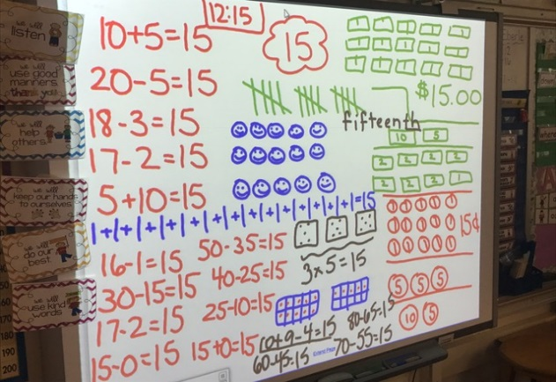
First Grade website:  www.fkefirstgrade.  weebly.com | “Learning Rocks!”

