Our Word Study List  - car  - what  - give  - out  - turn  Word Family: Students should know how to read and write words with the _ar spelling pattern.  Examples: star, far | Mrs. Eberle’s Super Class News  News for the Week of October 23, 2017
Monday, October 23, 2017

- Home practice packet

Tuesday, October 24, 2017

- Wear tennis shoes today for P.E.
- Home practice packet

Wednesday, October 25, 2017

- Hat Day! Bring in $1.00 donation to go toward helping those with epilepsy.
- Home practice packet

Upcoming Events
10/25 – Hat Day! Bring $1.00.
11/3 – Zoo trip!
11/7 – No school
11/8 – School pictures for grades K-1
October
Birthdays

Travis 10/8
Lilly 10/11
Emma 10/17

Thursday, October 26, 2017

- Return library book
- Home practice packet
Friday, October 27, 2017

- Return home practice packet
- Have a great weekend!

*PLEASE SEE OTHER SIDE.
Special Classes  Monday: Art  Tuesday: P.E.,  Wednesday: Music, guidance  Thurs: Library  Friday: Computer Lab  Lunch: 12:30-1:00  Although it rarely happens, lunch times are subject to change due to delays, special activities, etc.  *********************Principal’s Club  Effort: Cal  Character: Delaney  Achievement: Austin  Student of the Week:  Michiru  Congratulations!  We are proud of you! | Notes:  *Welcome back to first grade! It was great seeing everyone return on Monday full of fun memories from fall break. This week we jumped right into our work for quarter two and they have not missed a beat. In reading we have started working on identifying the differences between fiction and non-fiction texts, including features specific to each genre. Writing workshop has been fun this week as we started learning about research and discussing an animal we would like to know more about. Our first step was brainstorming questions about an owl. We will then use these questions to determine our chapters. In math we have moved into comparing numbers, including using the symbols for greater than less than and equal to.  *Parent teacher conference times are coming home today. If you find that this time will not work for you, please let me know and we will find an alternative. aeberle@nafcs.k12.in.us  *Learn at Every Turn will take place next Friday, October 27. This is one of the most exciting days of the year! Because our day will be jam-packed with fun, we will have our word study check on Thursday, October 27. Also, we do not have many volunteers signed up to help with our class that day. If you would like to volunteer, please sign up at:  http://bit.ly/LAET2017  *Save the date! First grade will be taking a field trip to the Louisville Zoo on Friday, November 3. All parents are welcome to attend! Chaperones must have a criminal history check on file and will meet us at the zoo that day. Please let me know ASAP if you plan to attend and have not yet returned the parent form.  Here are some of our friends on 50’s day!  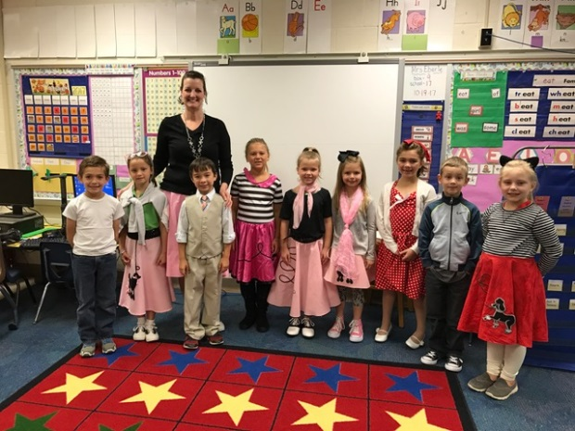
First Grade website:  www.fkefirstgrade.  weebly.com | “Learning Rocks!”

