Our Word Study List  - came  - rain  - then  - next  - thank  Word Family: Students should know how to read and write words with the _ame spelling pattern.  Examples: same, blame | Mrs. Eberle’s Super Class News  News for the Week of November 6, 2017
Monday, November 6, 2017

- Home practice packet

Tuesday, November 7, 2017

- NO SCHOOL TODAY DUE TO CONFERENCES
- Home practice packet

Wednesday, November 8, 2017

- School pictures are today!
- Home practice packet

Upcoming Events
11/7 – No school
11/8 – School pictures for grades K-1
November
Birthdays

Cal 11/11
Lexi 11/12

Thursday, November 9, 2017

- Return library book
- Home practice packet
Friday, November 10, 2017

- Wear red, white, and blue today!
- Return your interview with an older person.
- Return home practice packet
- Have a great weekend!

*PLEASE SEE OTHER SIDE.
Special Classes  Monday: Art  Tuesday: P.E.,  Wednesday: Music, guidance  Thurs: Library  Friday: Computer Lab  Lunch: 12:30-1:00  Although it rarely happens, lunch times are subject to change due to delays, special activities, etc.  *********************Principal’s Board  Effort: Bella  Character: Michi  Achievement: Loralei  Student of the Week:  Izzy  Congratulations!  We are proud of you! | Notes:  *This week we continued to work hard on understanding nonfiction text features and their importance to the things we read. We have learned about the index, glossary, table of contents, diagrams, captions, maps, and bold words. These are things they could point out during their reading at home.  *REMINDER – Our first project from our Thanksgiving packet is due on Friday, November 10. This is the interview with an older person. We always enjoy sharing these in class and hearing how times have changed. If this is the first you are hearing of this project, please let me know and I will send home another packet.  * REMINDER – There will not be school on Tuesday, November 7 due to parent teacher conferences.  *Wednesday, November 8 is school picture day for first grade!  *Don’t forget to wear red, white, and blue on Friday, November 10 for Veteran’s Day!  *Thank you for all of your help with the zoo field trip. We had a great day!  *We will be working on -0 facts in math next week and testing on Friday since these facts are pretty fast and easy!  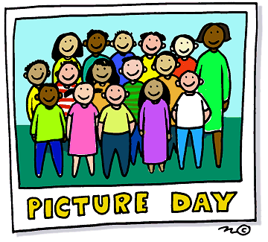
First Grade website:  www.fkefirstgrade.  weebly.com | “Learning Rocks!”

