Our Word Study List  No new words for our short week!  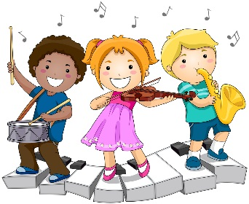 | Mrs. Eberle’s Super Class News  News for the Week of December 18, 2017
Monday, December 18, 2017

- No home practice tonight!

Tuesday, December 19, 2017

- Bring your gingerbread house goodies today!
- No PE today due to our party!

Wednesday, December 20, 2017

- Sleep late today!

Upcoming Events
12/19 – Holiday party, 12:45
12/20 – Winter break begins
December
Birthdays

Sophia 12/3
Bentlee 12/9

Thursday, December 21, 2017

- Do something fun!

Friday, December 22, 2017

- Spend time with your family!

*PLEASE SEE OTHER SIDE.
Special Classes  Monday: Art  Tuesday: P.E.,  Wednesday: Music, guidance  Thurs: Library  Friday: Computer Lab  Lunch: 12:30-1:00  Although it rarely happens, lunch times are subject to change due to delays, special activities, etc.  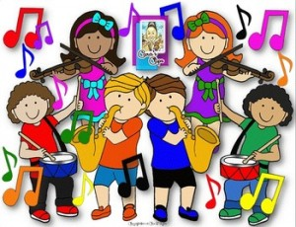  *********************Principal’s Board  Effort: Travis  Character: Hadley  Achievement: Sophia  Student of the Week:  Congratulations!  We are proud of you! | Notes:  * Our holiday party will be here soon! Please join us on Tuesday, December 19 from 12:45-1:45 as we party down a bit before the holiday break. A note was sent home regarding volunteering and sending in items for the party. Here is the link to sign up to help or send in items: http://www.signupgenius.com/go/30e0d4ea4a82aa46-mrs  Thank you for your help! The newsletter is also on the website if that makes it easier to open and click on this link.  *Reminder – Students may leave with parents after the party without it being counted as a “tardy” as long as they are signed out in the classroom.  *No home practice next week!  *This week we worked on comparing and contrasting stories in our author study about Jan Brett. These books are always fun to read and admire the illustrations, especially in the cold months. In writing we did some more informational stories about animals and they did a nice job revising and editing. In math we took our quarterly test and -10 fact check. They are such a sharp group of mathematicians! Anytime we finish up a skill and I offer a challenge, they are so eager to try it!  *On December 18 we will be learning about winter holidays around the world as we “travel” through various countries (other first grade classrooms). Don’t be surprised if they come home tired from all of their travels on Monday and want to show you their passports!  *Just a reminder that students may have a water bottle in class. It is great if they can bring one since we do not a water fountain in our room. Students who do not currently have one have to go out in the hall to get a drink.
First Grade website:  www.fkefirstgrade.  weebly.com | “Learning Rocks!”

