Our Word Study List  1.know  2.after  3.because  4.very  5.friend  Word Family: Students should know how to read and write words with the _ow spelling pattern.  Examples: snow, show | Mrs. Eberle’s Super Class News  News for the Week of March 5, 2018
Monday, March 5, 2018

- Home practice packets

Tuesday, March 6, 2018

- Wear tennis shoes for PE today!
- Home practice packets

Wednesday, March 7, 2018

- Home practice packet

Upcoming Events
3/12 – Reading Rodeo 5:30-7:00 (come anytime)
March
Birthdays

Jack S. 3/4

Thursday, March 8, 2018

- Return your library book today!
- Home practice packet
Friday, March 9, 2018

- Return home practice and book bags today!
- Have a great weekend!

*PLEASE SEE OTHER SIDE.
Special Classes  Monday: Art  Tuesday: P.E.,  Wednesday: Music, guidance  Thurs: Library  Friday: Computer Lab  Lunch: 12:30-1:00  Although it rarely happens, lunch times are subject to change due to delays, special activities, etc.  *********************Principal’s Board  Effort: Jane  Character: Jack M.  Achievement: Lilly  Student of the Week:  Hudson  Congratulations!  We are proud of you! | Notes:  * This week in reading we worked on figuring out if the story was told by a narrator or a character in the story. There are key words that always help us figure it out (I, my, they, them). Knowing whose point of view is being represented is a good step toward reading comprehension. We then worked on comparing and contrasting two stories with the same main characters. This is easy to do with books in a series like Arthur. In writing we wrapped up our latest persuasive writing piece about why FKE is the best school. In math we continued to work on fractions! We learned to partition (divide) shapes into fair/equal parts and shade specific portions. We have already been working on how to also read and write these fractions. I know I have bragged about them before, but their problem solving skills continue to improve and move well beyond typical first grade strategies.  *Wednesday, March 7 will be our quarter 3 math test. This will cover coins, story problems with three digits, partitioning (dividing) shapes, and fractions (___out of ___ parts). They also need to know the difference between halves and fourths/quarters. I think they will do a great job!  *Don’t forget that our Reading Rodeo will be Monday, March 12 from 5:30 to 7:00. Stop in anytime that night for some reading fun!  *Thank you for returning the book baggies! Having them all in by Friday allows us to move them on to the next classmate.  *Thank you to Mrs. Shiga, Michi’s mom, for coming in and teaching us about Japanese culture. We all learned a lot and were fascinated by the similarities and differences between Japan and America.  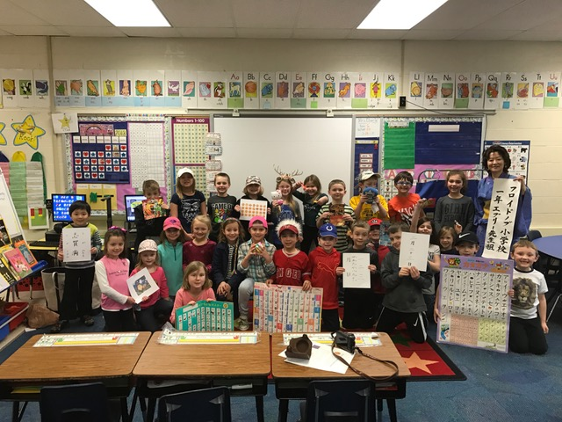
First Grade website:  www.fkefirstgrade.  weebly.com | “Learning Rocks!”

