Our Word Study List  - in  - they  - big  - here  - with  Word Family: Students should know how to read and write words with the _in spelling pattern.  Examples: fin, spin | Mrs. Eberle’s Super Class News  News for the Week of August 28, 2017
Monday, August 28, 2017

- Rock Star Day (These days are optional!)
- Home practice packet

Tuesday, August 29, 2017

- Boy / Girl Band Day!
- Wear tennis shoes today for P.E.
- Home practice packet

Wednesday, August 30, 2017

- 80’s Day!
- Home practice packet

Upcoming Events
9/4 – Labor Day – No school
August Birthdays

Brianne 8/3
Remi 8/21
Aly 8/22
Izzy 8/27
Bella 8/28

Thursday, August 31, 2017

- Elvis Day!
- Return library book
- Home practice packet
Friday, September 1, 2017

- 90’s Day!
- Return home practice packet
- Have a great weekend!

*PLEASE SEE OTHER SIDE.
Special Classes  Monday: Art  Tuesday: P.E.,  Wednesday: Music, guidance  Thurs: Library  Friday: Computer Lab  Lunch: 12:30-1:00  Although it rarely happens, lunch times are subject to change due to delays, special activities, etc.  *********************Principal’s Club  Effort: Lilly  Character: Sophia  Achievement: Travis  Student of the Week:  Tessa  Congratulations!  We are proud of you! | Notes:  *Thank you for sending a snack and water bottle each day!  *I wanted to let you know what an amazing job the kids did with the eclipse on Monday! We practiced in the morning and everyone completely followed the directions to not look up until they were told to put their glasses on. During the actual eclipse they all put the glasses on correctly, peeked for a few seconds, took a little break, and then peeked a bit more. When it was time to go back in everyone looked forward and did exactly what we practiced. You would have been proud of them!  *We had our first word study check on Friday and they did a great job! The first one can be tough because they have never done anything like this before. They will all be professionals now that they have gone through the routine once.  *We will also take our first math assessment on Wednesday, August 30 and they are ready! It will include recognizing/writing numbers to 80 and composing / decomposing numbers up to 80 using ten frames. They will need to be able to fill in the missing numbers when given a line of numbers between 1 and 80 with some blank boxes. The work they have been bringing home shows good examples of items that will be on the assessment. We will also take our timed test on +2 facts. I think they will do well!  *We started guided reading groups this week! It has been great getting to work with them in small groups and listening to everyone read!  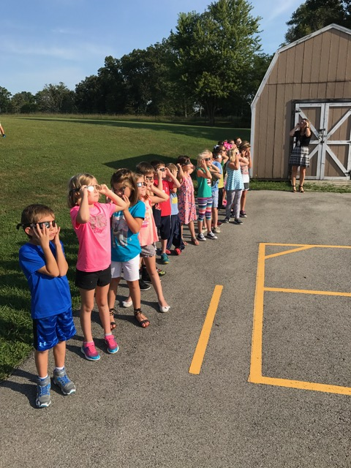  Here we are practicing for the eclipse!
First Grade website:  www.fkefirstgrade.  weebly.com | “Learning Rocks!”

